**Automatic Accident Detection System**

**Team Name:**

SD_CARD

|  |  |  |
| --- | --- | --- |
| **CT Reference No** | **Name** | **Position** |
| ct20172257624 | Deeban N | Team Leader |
| ct20172255298 | Santhosh M | Team Member |

**Department:**

Computer Science and Engineering (B.E - CSE)

**College Name:**

M. Kumarasamy College of Engineering (Autonomous), Karur

(2016 - 2020 Batch)

**1. ABSTRACT:**

Our idea is to detect the accidents and send proper information to the nearby hospitals or concerned authorities automatically. Nowadays, due to late and wrong information of accidents to the concerned authorities and some delay in reaching of the ambulance to the accident location we are losing many valuable lives. To reduce those kinds of activities we have introduced a system called Automatic Accident Detection System using sensors and location trackers. Our system will be fixed in the vehicle. Sensors installed in a vehicle detect the accident's location, and also the vehicle's speed just before the accident and the number of passengers inside the vehicle. Then, those sensors send an alert signal to a monitoring station or nearby hospitals and to the ambulances. Immediately, the monitoring station tracks the location where the accident has occurred and alerts the authorities concerned to send the rescue team.

**2. INTRODUCTION:**

The rapid rise of technology and infrastructure has made our lives easier. The high demand of automobiles has also increased the traffic hazards and road accidents. Life of the people is under high risk. The delay in reaching of the ambulance to the accident location and the traffic congestion in between accident location and hospital increases the chances of death of the victim. To overcome this problem our automatic detection system comes to the rescue. This proposed sensor based accident detection system helps to reduce the loss of life due to accidents and also reduces the time taken by the ambulance to reach the hospital. To detect the accident there is a vibration sensor and to verify it there is a temperature sensor and location tracker to track the locations with the help of GPS present in the vehicle and sends messages about the location to the respective guardian and rescue team. With the help of sensor signal, a severe accident due to an obstacle can be recognized. Thus, the emergency help team can immediately trace the location through the GPS module, after receiving the accident location information, action can be taken immediately. This sensor based accident detection system is powered by Atmega 328 microcontroller it consists of Display, Vibration and Temperature sensor, Onboard sensor for alert messages and GPS for location tracker. This automatic accident detection system project is useful in detecting the accident.

**3. TECHNOLOGY STACK :**

* GPS sensor - To Track the Location
* Onboard sensor - Sends a message to the concerned Authorities
* Conventional vehicular sensor system (Vibration Sensor and Temperature Sensor) - To detect and verify the accidents
* Microcontroller – To control and connect each and every sensors for input and output

**4. WORKING METHODOLOGY:**

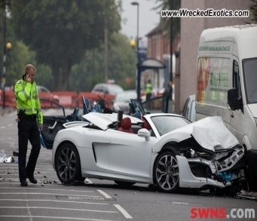 **(**Temperature & vibration sensor**)**

**Accident Detected**

No

No Accident occurs

**Conventional vehicular sensor system**

**Car Accidents YES**

**Smaller Accidents**

**(Even for bigger Accidents)**



**GPS Sensor**

**Victim of Accidents Message Passing**

**Click Manually**

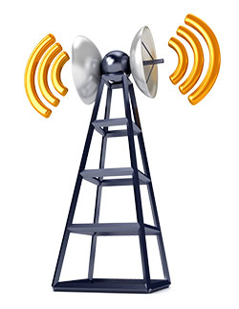

**Rescue Team**

**Concerned Authorities**

Whenever the accident is caused the vibration sensor (which is activated from the start of the vehicle) reads the vibrations of the vehicle and if the vibrations are more then it activates the temperature sensor to verify it is an accident or not by denoting the temperature in the surrounding. If temperature is also more then the convectional vehicular system activates the onboard sensor then with the help of GPS tracker the onboard sensor will alerts the nearby hospitals and the sends location to the ambulances and to the emergency contacts of the vehicle owner. Thus we can save the valuable life.

**5. CONCLUSION**

Nearly 1,50,000 people die due to road accidents per year. In that 75,000 people die due to late coming of medical help, since the accident information goes late to them. If we implement our idea in our real world it will used to reduce those deaths by giving treatment on time and save more valuable lives.